SUPER SET ID:7638914
DESIGN PATERNS AND PRINCIPLES
Exercise 1: Implementing the Singleton Pattern
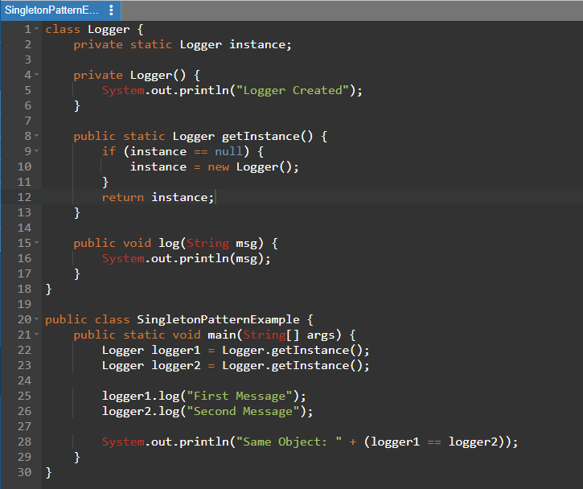
OUTPUT:
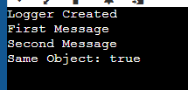

Exercise 2: Implementing the Factory Method Pattern
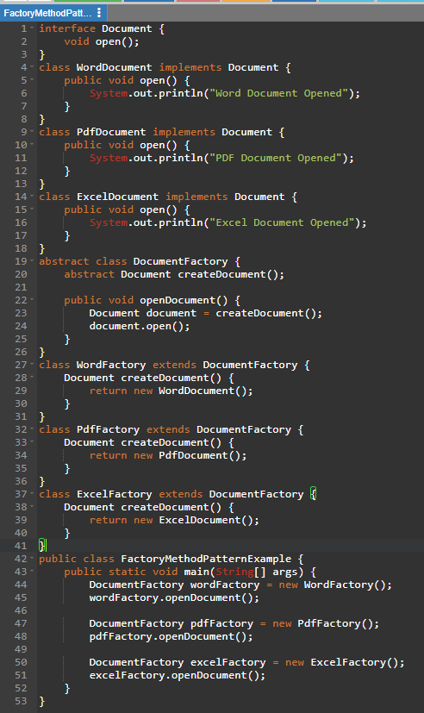
OUTPUT:
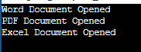

Exercise 3: Implementing the Builder Pattern
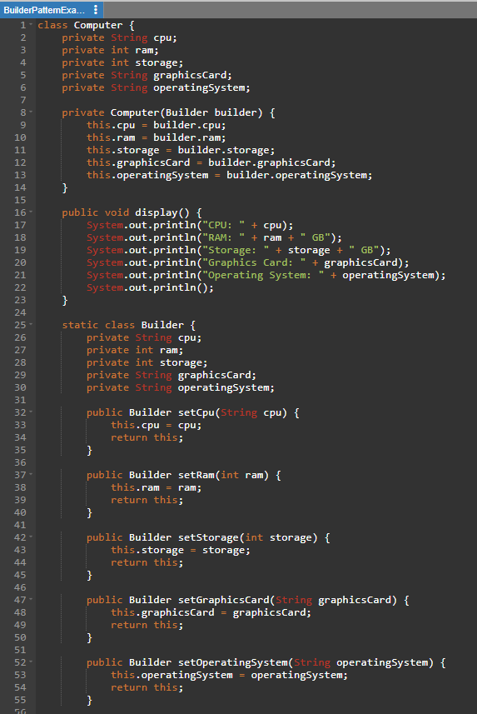
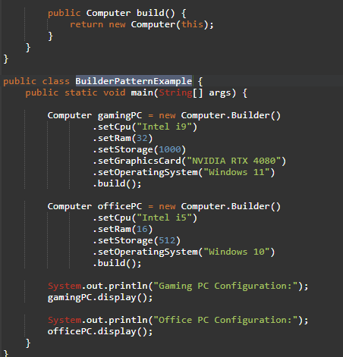

OUTPUT:
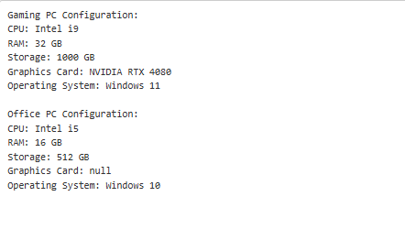
Exercise 4: Implementing the Adapter Pattern
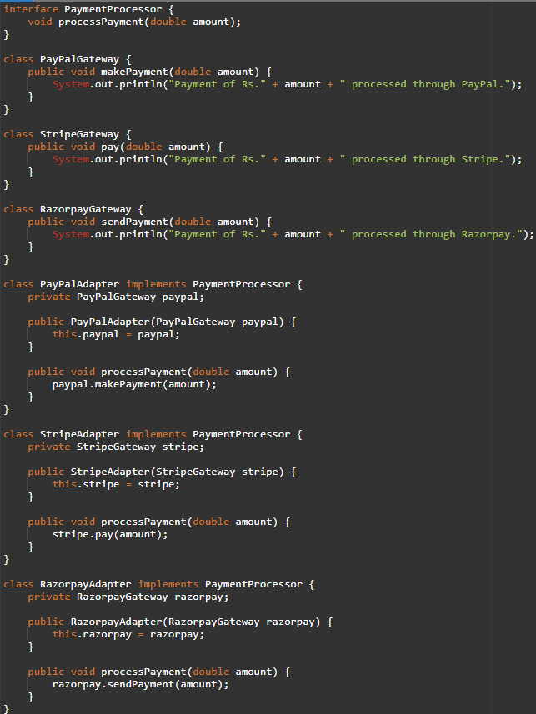
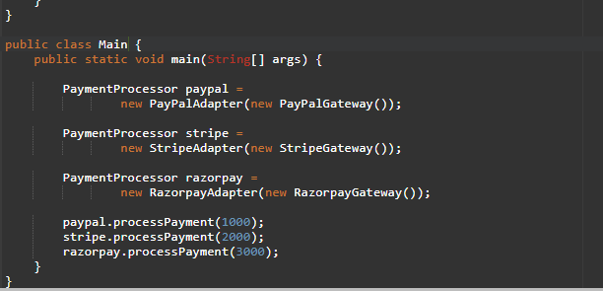
OUTPUT:
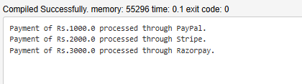

Exercise 5: Implementing the Decorator Pattern
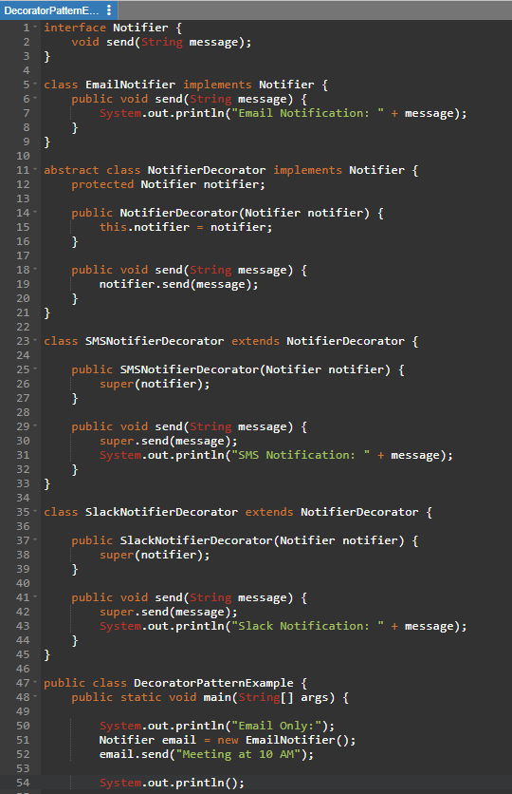
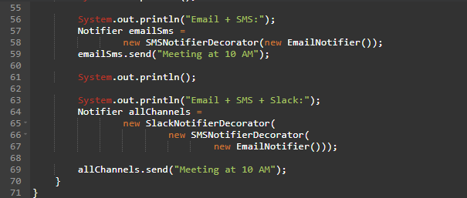
OUTPUT:
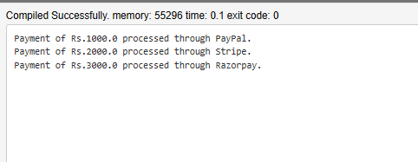

Exercise 6: Implementing the Proxy Pattern
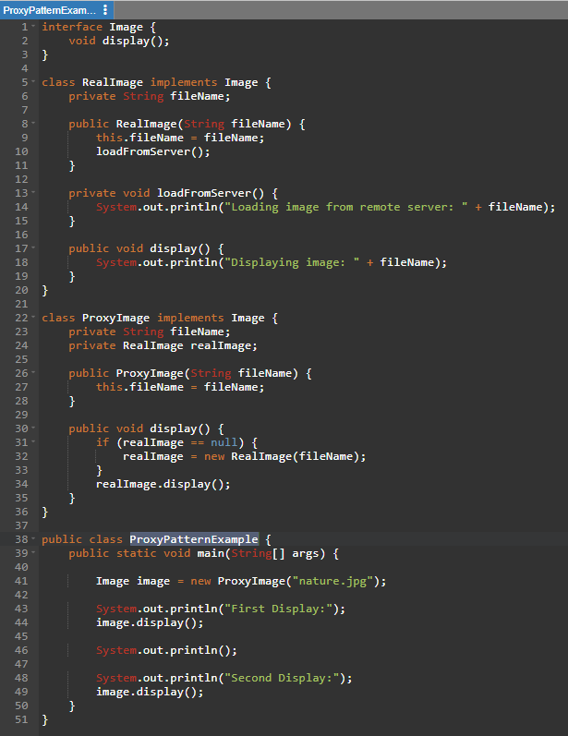
OUTPUT:
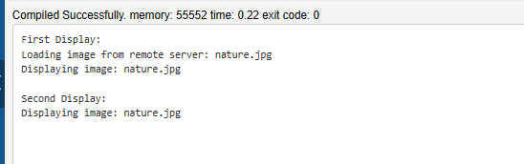

Exercise 7: Implementing the Observer Pattern
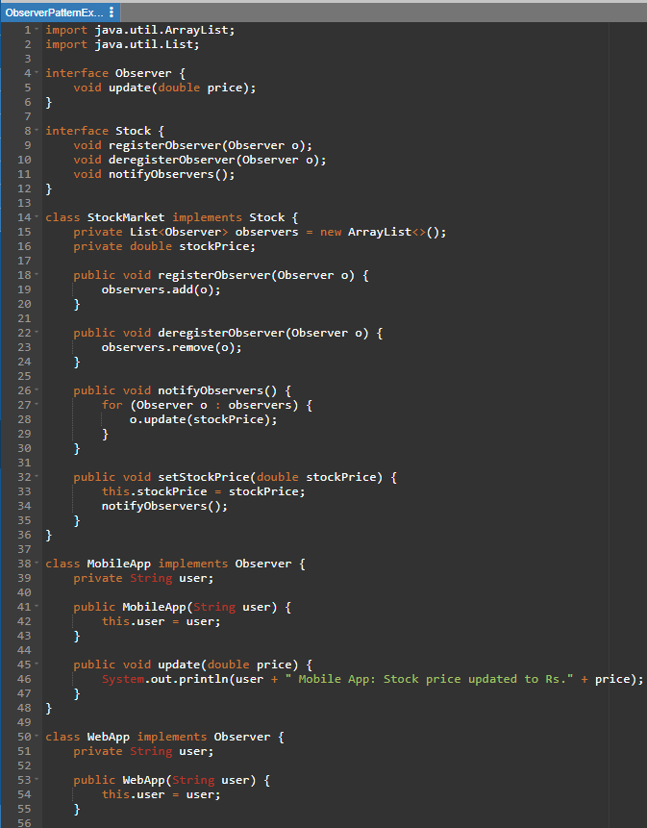
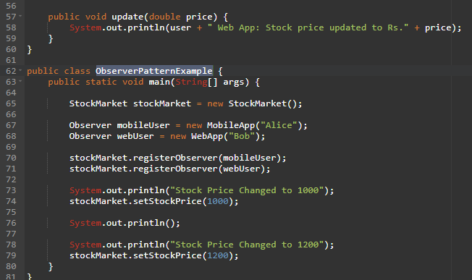
OUTPUT:
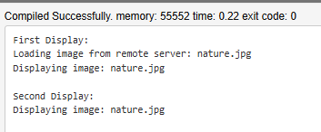

Exercise 8: Implementing the Strategy Pattern
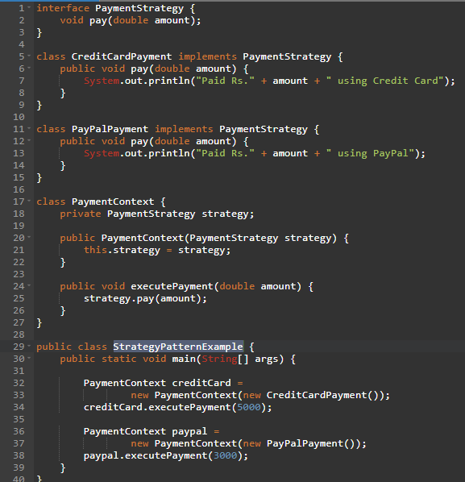
OUTPUT:
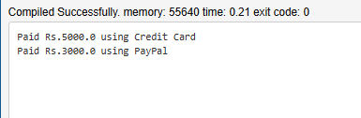

Exercise 9: Implementing the Command Pattern
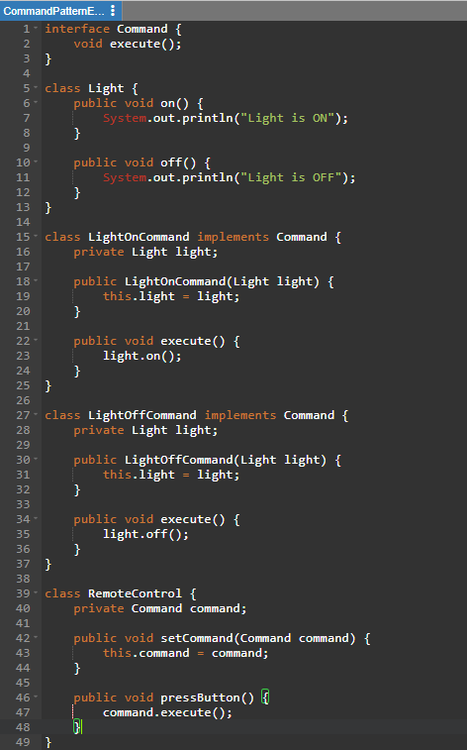
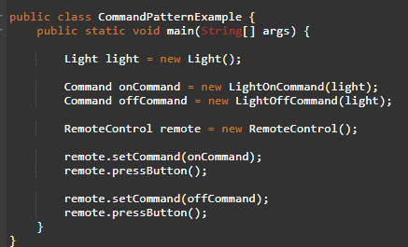
OUTPUT:
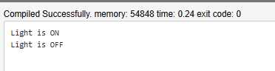

Exercise 10: Implementing the MVC Pattern
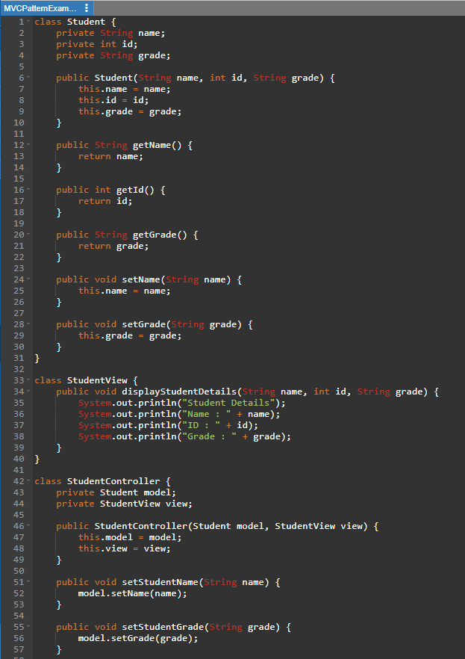

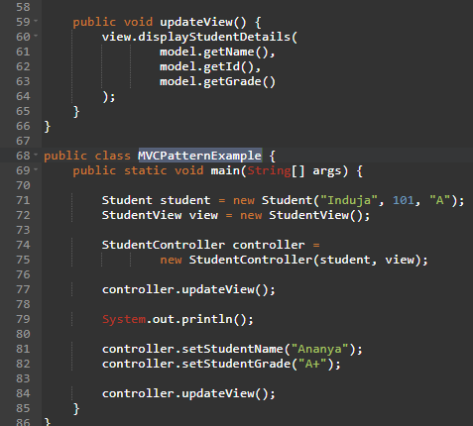
OUTPUT:
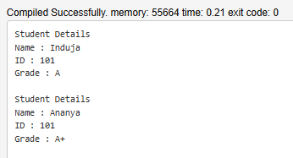

Exercise 11: Implementing Dependency Injection
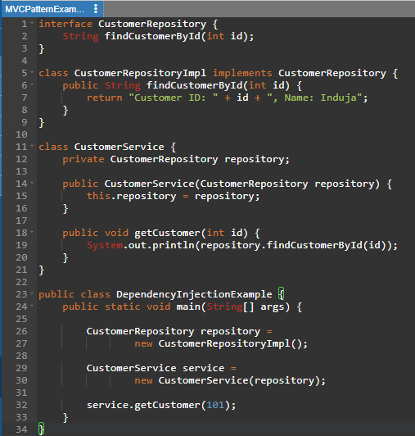
OUTPUT:
